NAME: RAJA RAYYAN AMEER
REG. NO.: 23-CP-25
SECTION: ALPHA
SUBJECT: ML&AI
DEPARTMENT: COMPUTER ENGINEERING
TEACHER: SIR SHAHID
LAB 5:
Task:
- Data Preprocessing:
- How did you handle missing values in the dataset?
- Why did we use get_dummies() for categorical variables?
- Model Training & Performance:
- What are the R² scores for the Linear Regression model on training and testing data?
- What does the difference between the train and test scores indicate?
- Ridge (L2) Regularization:
- What are the train and test scores for Ridge Regression?
- How does Ridge Regression help in reducing overfitting?
- Lasso (L1) Regularization:
- What are the train and test scores for Lasso Regression?
- How does Lasso affect feature selection compared to Ridge?
- Comparison & Visualization:
- Compare the performances of Linear, Ridge, and Lasso Regression models.
- Based on the visualizations, which model performed best and why?
- Regularization Impact:
- What happens when you increase the alpha value in Ridge and Lasso Regression?
- If you had to choose one model for this dataset, which one would it be and why?

Program:
# Step 1: Import Libraries
import numpy as np
import pandas as pd
import matplotlib.pyplot as plt
import seaborn as sns
from sklearn.model_selection import train_test_split
from sklearn.metrics import mean_squared_error, r2_score
from sklearn.linear_model import LinearRegression
from sklearn.linear_model import Ridge
from sklearn.linear_model import Lasso

# Step 2: Dataset Reading
data = pd.read_csv("Lab 5 Melbourne Housing Full Dataset.csv")
print("Unique Values:\n", data.nunique())

# Step 3: Dataset Features
print("Dataset Shape:\n", data.shape)
print("Missing Values in the Dataset:\n", data.isna().sum())

# Step 4: Handling Missing Values and Strings
data = data.dropna(subset=["Price"])

data["Distance"] = data["Distance"].fillna(data["Distance"].mean())
data["BuildingArea"] = data["BuildingArea"].fillna(data["BuildingArea"].mean())

#Encode the Suburb column into numeric dummy variables
data = pd.get_dummies(data, columns=["Suburb"], drop_first=True)

suburb_cols = [col for col in data.columns if col.startswith("Suburb_")]
x = data[['Rooms', 'Distance', 'BuildingArea'] + suburb_cols]
y = data['Price']

# Step 5: Splitting the Dataset
x_train, x_test, y_train, y_test = train_test_split(x, y, test_size = 0.2, random_state = 2)

# Step 6: Model Training
#Using Linear Regression
model = LinearRegression().fit(x_train, y_train)
model_test = model.score(x_test, y_test)
model_train = model.score(x_train, y_train)

#Using Ridge,L2 Regularization
ridge_model = Ridge(alpha = 50, max_iter = 100, tol = 0.1)
ridge_model.fit(x_train,y_train)
ridge_test = ridge_model.score(x_test,y_test)
ridge_train = ridge_model.score(x_train,y_train)

#Using Lasso,L1 Regularization
lasso_model = Lasso(alpha = 50, max_iter = 100, tol = 0.1)
lasso_model.fit(x_train,y_train)
lasso_test = lasso_model.score(x_test,y_test)
lasso_train = lasso_model.score(x_train,y_train)

print("\nModel R2 Scores ")
print(f"Linear Regression\nTrain: {model_train:.4f} | Test: {model_test:.4f}")
print(f"Ridge Regression\nTrain: {ridge_train:.4f} | Test: {ridge_test:.4f}")
print(f"Lasso Regression\nTrain: {lasso_train:.4f} | Test: {lasso_test:.4f}")

#Step 7: Visualization
sns.set_style("whitegrid")
models = ["Linear", "Ridge", "Lasso"]
train_scores = [model_train, ridge_train, lasso_train]
test_scores = [model_test, ridge_test, lasso_test]

bar_width = 0.3
index = np.arange(len(models))

plt.figure(figsize = (9, 5))
plt.bar(index, train_scores, width = bar_width, label = "Train Score", color = "royalblue", alpha = 0.8)
plt.bar(index + bar_width, test_scores, width = bar_width, label = "Test Score", color = "orange", alpha = 0.8)
plt.xlabel("Models", fontsize=12)
plt.ylabel("R² Score", fontsize=12)
plt.title("Train vs Test R² Scores — Linear, Ridge & Lasso", fontsize=13)
plt.xticks(index + bar_width / 2, models)
plt.ylim(0, 1)
plt.legend()
plt.tight_layout()
plt.show()

# Step 8: Effect of Alpha on Ridge and Lasso
alphas = [0.1, 1, 10, 50, 100, 500, 1000]
ridge_train_scores, ridge_test_scores = [], []
lasso_train_scores, lasso_test_scores = [], []

for a in alphas:
r = Ridge(alpha = a, max_iter = 1000).fit(x_train, y_train)
ridge_train_scores.append(r.score(x_train, y_train))
ridge_test_scores.append(r.score(x_test, y_test))

l = Lasso(alpha = a, max_iter = 1000).fit(x_train, y_train)
lasso_train_scores.append(l.score(x_train, y_train))
lasso_test_scores.append(l.score(x_test, y_test))

fig, axes = plt.subplots(1, 2, figsize=(14, 5))

axes[0].plot(alphas, ridge_train_scores, marker = 'o', label = "Train", color = "royalblue")
axes[0].plot(alphas, ridge_test_scores, marker = 'o', label = "Test", color = "orange")
axes[0].set_xscale("log")
axes[0].set_title("Ridge: Effect of Alpha")
axes[0].set_xlabel("Alpha (log scale)")
axes[0].set_ylabel("R² Score")
axes[0].legend()

axes[1].plot(alphas, lasso_train_scores, marker='o', label="Train", color="royalblue")
axes[1].plot(alphas, lasso_test_scores, marker='o', label="Test", color="orange")
axes[1].set_xscale("log")
axes[1].set_title("Lasso: Effect of Alpha")
axes[1].set_xlabel("Alpha (log scale)")
axes[1].set_ylabel("R² Score")
axes[1].legend()

plt.tight_layout()
plt.show()
Output:
Unique Values:
Suburb 10
Rooms 5
Distance 82
BuildingArea 87
Price 90
dtype: int64
Dataset Shape:
(100, 5)
Missing Values in the Dataset:
Suburb 0
Rooms 0
Distance 7
BuildingArea 13
Price 3
dtype: int64
Model R2 Scores
Linear Regression
Train: 0.8678 | Test: 0.8727
Ridge Regression
Train: 0.8269 | Test: 0.9096
Lasso Regression
Train: 0.8675 | Test: 0.8714
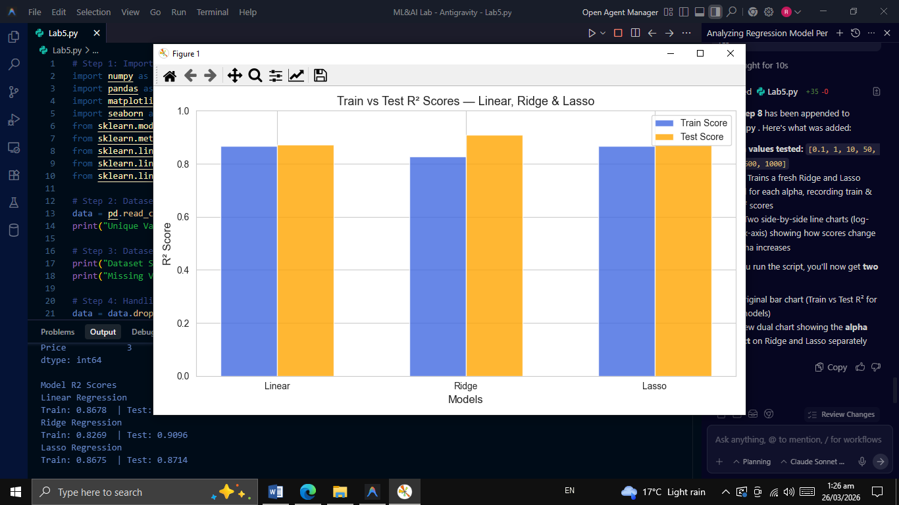
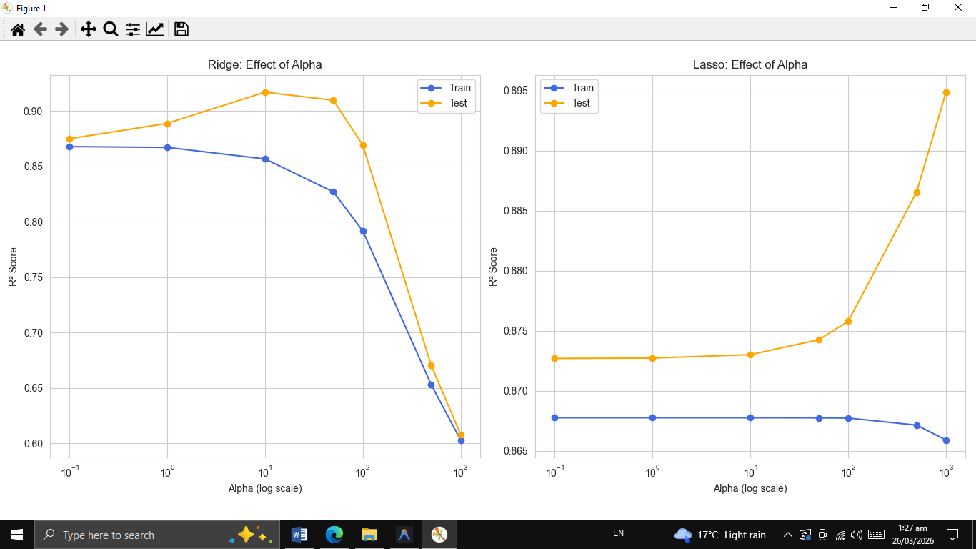
Best Choice for the Model:
Ridge Regression is the best model because it achieves the highest test R² (~0.91), the smallest train-test gap (least overfitting), and handles the many correlated suburb dummy variables better than Lasso.
THE END

